# `Coin- Thrace, CHERSONESOS, Hemidrachm. Lion

Thrace, Chersonesos. 400 - 350 BC. Silver Hemdrachm. 12.30mm, 2.24g. Forepart of a lion. / Quadrapartite incuse with symbols in the shallower depressions. Fine.

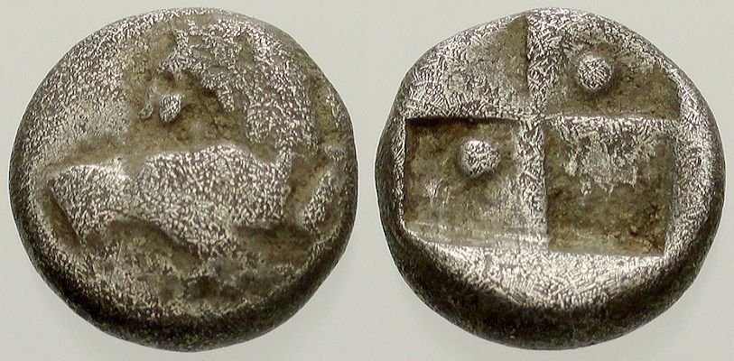

| Shipping details |
| --- |
| Ralph J Coffman Jr  149 Atlantic Ave  Swampscott MA 01907-2427  United States |

## Order details

|  |  |  |  |
| --- | --- | --- | --- |
| Item title | Available actions | Shipping & handling (estimated delivery*) | Price |

[Printer version](http://payments.ebay.com/ws/eBayISAPI.dll?ViewPaymentStatus&transid=0&userloginid=802-867&orderid=142249895013&printerversion=true&itemid=400499874149)

|  |  |  |
| --- | --- | --- |
| Seller: | [**Member id** ancient_treasures](http://myworld.ebay.com/ancient_treasures) ( [**Feedback Score Of** 54481](http://feedback.ebay.com/ws/eBayISAPI.dll?ViewFeedback&userid=ancient_treasures)) | [Contact seller](http://contact.ebay.com/ws/eBayISAPI.dll?ShowCoreAskSellerQuestion&frm=3998&iid=0&redirect=0&requested=ancient_treasures) |

|  |  |  |  |  |
| --- | --- | --- | --- | --- |
| Order # 142249895013  Paid on Jun-07-13 via PayPal | | | | |
|  |  | |  | | --- | |  | | |  |  | | --- | --- | | [Contact seller](http://contact.ebay.com/ws/eBayISAPI.dll?ShowCoreAskSellerQuestion&frm=3998&iid=400499874149&redirect=0&requested=ancient_treasures) |  | | |  |  |

|  |  |  |  |  |  |  |  |  |  |
| --- | --- | --- | --- | --- | --- | --- | --- | --- | --- |
|  | [**Item Title:**ANTHROPOMORPHIC NEOLITHIC FERTILITY FIGURINE, VINCA**- opens in a new window or tab**](http://cgi.ebay.com/ws/eBayISAPI.dll?ViewItem&item=400499874149)  Item Id:400499874149 - Price: US $151.50  Quantity:1  Having a problem with this purchase? [We can help](javascript:;) | |  | | --- | |  | | |  |  | | --- | --- | | [Leave feedback](http://feedback.ebay.com/ws/eBayISAPI.dll?LeaveFeedbackShow&useridfrom=802-867&useridto=ancient_treasures&item=400499874149&transactid=0) |  | | | Standard Shipping : US $5.00  USPS First Class Package®  Estimated delivery: Mon. Jun. 24 - Thu. Jun. 27  Package 1 of 1    Shipment details: [9402111201080341711664](javascript:;) | | US $151.50 |
|  | [**Item Title:**051. Greek Silver Coin. CHERSONESOS, Hemidrachm. Lion**- opens in a new window or tab**](http://cgi.ebay.com/ws/eBayISAPI.dll?ViewItem&item=400499882903)  Item Id:400499882903 - Price: US $25.00  Quantity:1  Having a problem with this purchase? [We can help](javascript:;) | |  | | --- | |  | | |  |  | | --- | --- | | [Leave feedback](http://feedback.ebay.com/ws/eBayISAPI.dll?LeaveFeedbackShow&useridfrom=802-867&useridto=ancient_treasures&item=400499882903&transactid=0) |  | | | Shipped with item above  Package 1 of 1    Shipment details: [9402111201080341711664](javascript:;) | US $25.00 |  |



|  |  |  |  |  |
| --- | --- | --- | --- | --- |
|  | |  | | |
|  | |  | | --- | |  | | [Ad Feedback](javascript:void(0);)|[AdChoice **- opens in a new window or tab**](javascript:void(0);) | | | |  |  |  |  |  |  |  |  |  |  |  |  |  |  |  |  |  |  |  |  | | --- | --- | --- | --- | --- | --- | --- | --- | --- | --- | --- | --- | --- | --- | --- | --- | --- | --- | --- | --- | | |  | | --- | | |  |  |  |  |  |  |  |  |  |  |  |  |  |  |  |  |  | | --- | --- | --- | --- | --- | --- | --- | --- | --- | --- | --- | --- | --- | --- | --- | --- | --- | | |  |  | | --- | --- | | Subtotal: | US $176.50 | |  | | | Shipping & handling: | US $5.00 | |  | | |  | | |  | | | Total: | US $181.50 | |  | | | | | |  |